National Data Toolkit Framework
Welcome to the Safeguarding Adults Board (SAB) Manager’s Network Data Toolkit. The purpose of this toolkit is to support and inform the work of Board Managers and quality and assurance sub group members (title of sub group might have local variations).
This toolkit aims to:
- Support and inform the work of Safeguarding Adults Board Managers, Safeguarding Leads or relevant sub groups
- Contain material that is relevant and helpful for and Safeguarding Adults Board Managers, Safeguarding Leads, Quality & Excellence Sub Groups when shaping their data ‘offer’ to their Partnerships.
The development of regular local data sets and the manner that they are offered to partners are likely be found wanting when considering specific issues in detail. The aim of this toolkit is to facilitate an overview of performance that supports partnerships conversations and identifies areas where further investigation is required.
All content will be moderated through the Safeguarding Adults Board (SAB) Manager’s Network – Contact Link: Deb_Ward@sandwell.gov.uk
We acknowledge the work undertaken by the West Midlands Safeguarding Leads and CCG Task & Finish Group on dashboard reviews and assurance in November 2019.

Purpose
The purpose of this toolkit is to enable and support the development of data sets and assurance tools including assurance frameworks and stories of difference as examples. This intelligence can inform emerging themes and priorities; and prompt a response from Partners.
A key function of Safeguarding Adults Boards is seeking assurance and this toolkit may assist Board Managers and/or appropriate subgroups and/or business teams when considering what good assurance means locally.
Sharing the right information, at the right time, with the right people, is fundamental to good practice in safeguarding adults but has been highlighted as a difficult area of practice.
Methodology and Design
The toolkit offers challenges that every Board will need to overcome if they are to succeed in using their data to improve services and prevent neglect and abuse in their area effectively and consistently.
Before you start to redesign your toolkit it might be useful to read what others have learnt about good practice : PRINCIPLES FOR THE DESIGN AND DEVELOPMENT OF DASHBOARDS: LITERATURE REVIEW.
CHALLENGE 1 – What is the data used for?
It is important that we understand what we are trying to achieve and ensure everything we do works towards achieving these goals.
- To instigate action to prevent death or serious harm
- To coordinate Partner intervention, monitoring etc.
- To facilitate early intervention to prevent harm
- To reduce impact (harm or potential harm) of circumstances and individuals
- To (identify and) reduce care and support needs
- To share good practice
- To identify trends and offer opportunity for analysis (e.g. low level harm trends link to risk of abuse)
- To reduce organisational risk and protect reputation.

Challenge 2 – What do we need to know before we design the data offer?
(This is not an exhaustive list but captures many of the questions you will need to answer before you start)
- Why is the dashboard being created?
  - To identify areas of risk / need
  - To identify areas and levels of outcome achieved
  - To identify trends in risk and service delivery
  - To identify areas where resources can be best assigned
  - To identify areas where shared (co-design / co-production) can be explored further

- Who is the dashboard for?
Partners: Departments or sections of workforce that would benefit from the insight.

- What questions do they need answered and how regularly?
  - Where is the need and when does it arise (costs, geographical and theme)
  - Where are services delivered (costs, geographical and theme)
  - What outcomes are achieved (costs, geographical and theme) (e.g. MSP, S.42 etc.)
  - How are we currently performing (training, timeliness, inspections, governance, employment – costs, geographical and theme)
  - How quickly does the situation change (given we are considering trends and not single events)? Is quarterly still appropriate?

- How much time will be spent considering the Dashboard?
  - This data should be used to drive the work of an audit or monitoring team, influence the strategy and report on performance. It is important enough to spend some considerable time to deliver and to maintain the accuracy of the information provided.

- How data-savvy is the audience?
  - The dashboard should not only be relevant to the audience but tell a story that can be understood.
    - The dashboard needs to present in a sequence that tells the story i.e. need, delivery, performance, opportunity for improvement

  - Data, Analysis and Supporting Commentary/Narrative
  - Commentary is often not included in dashboards. The data providers often concentrate on the provision of numbers and not on the analysis of the data provided. This contextualisation of the data should not be underestimated.

- The importance of accurate data and intelligence
  - It can be argued that the data and commentary provided needs to be 100% accurate, but is this the case? Considering the use of the dashboard is to identify generic trends, delivery and outcomes of the shared partner delivery and outcomes accuracy, or quality levels, needs to be considered carefully. Accepting that the provider needs only to be 95% accurate can save huge amount of time.
  - There is a need to make sure that any data inaccuracies or outliers are explained. If "No value" or "Encrypted Keywords" appears in the data, there should be an explanation in the commentary.

- What tools are available?
  - Managing complex data sets across agencies, offering analysis and commentary is difficult and you will almost certainly need the support of a data/intelligence team and should use their expertise to not only produce the dashboard but to consider what the data can reveal if subject to appropriate analysis.

- How much time will this take?
  - Some of the difficulty in producing a dashboard is that it is seen as an ‘add-on’ to everyone’s day job.
  - If the data can be ‘pushed’ by systems into the dashboard rather than ‘pulled’ (data requested quarterly) a huge amount of time can be saved. This also guarantees a consistency of provision.

- Data Protection
  - Arranging a data sharing agreement with organisations data / intelligence teams will overcome the repeated difficulty in data sharing experienced without it in place.

- What format should it be in (when the data is collected and when the dashboard is presented)?
- On Line, Hard Copy, Digital
- Is the presentation of the data flexible, searchable?
- Do we want to see data sets or is a pictorial representation of the data enough?

- What other members of the organisation do you need on your team?
  - Who needs to be involved in the review of the dashboard
  - Who needs to monitor and provide information in the future?

- Which metrics should the dashboard include?
  - When considering performance, what are the metrics that Partners already use to monitor performance in Safeguarding provision?

- What should the dashboard not include?
  - Are there certain metrics that partners are deprioritising?
  - Is there sensitive data that we can’t or shouldn’t use?

- Does the dashboard need more than just visuals?
  - Whilst commentary has already been mentioned – Is it needed?

- Which part of the dashboard is most important?
  - Whilst the dashboard should tell a story it is also important that the most important part of the dashboard (in terms of content) should figure most.

- What types of graphs fit the data best?
  - If we are plotting trends over time, we might use line and area charts. If comparing values, a bar or column visual instead.
  - Can we choose if the dashboard is digital, can we provide options?

- Should benchmarks or goals be included?
  - It is useful to measure risk, delivery and performance against targets and benchmarks (best in class, Govt. targets etc.)
  - Can you identify these?
  - Does the dashboard need to be segmented?

- Is there a need to think about how to segment data
  - Geographical area, Department, Service, Need etc.

- What actions do you want to drive out of each part of the dashboard?
  - Every part of the dashboard should be targeted in an area we have identified an achievable outcome. Identify what that outcome is – For Example:
    - Monitoring service delivery
    - Identifying trends and changes in risk
    - Supporting task and finish groups to meet unusual need. (etc.)

- Is there a need for more than one version of the dashboard?
  - Can the dashboard be manipulated easily to meet partner’s needs?
  - Does the dashboard have more than one audience (Public?)

- Who owns the dashboard?
  - It is important that the SAB owns the dashboard in order that all partners can be assured that the information in it is not partisan.

- Who needs access to the dashboard?
  - Make sure that the dashboard is shared appropriately:
    - Those who can benefit from it receive it, and
    - Those that should not see it do not.

- How should it be distributed it?
  - Automated?
  - At the Board after being ratified by Performance?
  - On the website?
  - Shared by email to stakeholders?
  - Any other way?

- Does the process need to be repeatable? How will we iterate on it?
  - Record the process of co-design in order that future reviews can repeat the process for a refresh.
  - The Dashboard needs regular reviews whilst not losing the benefits that trend analysis offer.

Care Act / Data Protection

Data sharing agreements can facilitate the passage of data between Partners. (example: https://weisf.essex.gov.uk/)

45 Supply of information
- If an SAB requests a person to supply information to it, or to some other person specified in the request, the person to whom the request is made must comply with the request if—
  - conditions 1 and 2 are met, and
  - condition 3 or 4 is met.
- Condition 1 is that the request is made for the purpose of enabling or assisting the SAB to exercise its functions.
- Condition 2 is that the request is made to a person whose functions or activities the SAB considers to be such that the person is likely to have information relevant to the exercise of a function by the SAB.
- Condition 3 is that the information relates to—
  - the person to whom the request is made,
  - a function or activity of that person, or
  - a person in respect of whom that person exercises a function or engages in an activity.
- Condition 4 is that the information—
  - is information requested by the SAB from a person to whom information was supplied in compliance with another request under this section, and
(b) is the same as, or is derived from, information so supplied.
(6) Information may be used by the SAB, or other person to whom it is supplied under subsection (1), only for the purpose of enabling or assisting the SAB to exercise its functions.
The Data Protection Act 2018 controls how your personal information is used by organisations, businesses or the government. The Data Protection Act 2018 is the UK's implementation of the General Data Protection Regulation (GDPR).
Summary of the Act:

- The Data Protection Act 1998 provides a framework to strike a balance between the rights of individuals and other competing interests.
- There are various ‘legitimising criteria’ under the Act for sharing personal data.
- The criteria for data sharing are stricter for more sensitive personal data.
- Myths surrounding what is required by the Data Protection Act 1998 have created unnecessary, and at times harmful, barriers to legitimate data sharing.
- Other issues relating to public interest, fair processing, and disproportionate effort.

The key principles are:

- Data protection legislation does not prohibit the collection and sharing of personal data – it provides a framework where personal data can be used with confidence that individuals’ privacy rights are respected.
- Emergency responders’ starting point should be to consider the risks and the potential harm that may arise if they do not share information.
- Emergency responders should balance the potential damage to the individual (and where appropriate the public interest of keeping the information confidential) against the public interest in sharing the information.
- In emergencies, the public interest consideration will generally be more significant than during day-to-day business.
- Always check whether the objective can still be achieved by passing less personal data.
- Category 1 and 2 responders should be robust in asserting their power to share personal data lawfully in emergency planning, response and recovery situations.
- The consent of the data subject is not always a necessary pre-condition to lawful data sharing.
- You should seek advice where you are in doubt – though prepare on the basis that you will need to make a decision without formal advice during an emergency.

Data Sets
Social Care Data Collection Sets – Local Authority
Public Health Data Collection – Local Authority
Education Data Collection Sets - Local Authority
Safeguarding Adult Collection - NHS – NHS (https://digital.nhs.uk/data-and-information/data-collections-and-data-sets/data-sets)
Short- and Long-Term Support (SALT) annual statutory return to the Department of Health
Crime Data Collection – Police
Government open data sets (https://data.gov.uk/)

Example Data Set (Southend On Sea Dashboard)
(Data collected and displayed from 2019 – presentation can be adjusted for required date range)
(Not an Exhaustive list)

Adult Social Care Benchmarking Tool (SAC) | Social Care – Concerns by Month
Benchmarking: | Contacts received
Concerns & Enquiries | Concerns raised
Enquiries commenced in year (by age) | Section 42 enquiries
Enquiries commenced in year (by gender) | Concerns not resulting in enquiries
Enquiries commenced in year (by ethnicity) | Conversion rate of concerns to enquiries
Enquiries commenced in year (by primary support reason) | Social Care – Presenting Issues & Source
Concluded enquiries (by risk type) | Presenting Issues (PI)
Concluded enquiries (by risk source) | Social Care - Concerns by PI - % prog. to enquiry
Concluded enquiries (by risk location) | % Concerns by Source
Risk Assessments | Monthly Concerns by Source
Risk Outcomes | Social Care - Individuals by age group (enquiries / concerns)
Mental Capacity | % of individuals with concerns/enquiries (by age group)
Making Safeguarding Personal | % of individuals by age group over time
 | Conversion of concerns to enquiries by age group

Social Care – Individuals by Gender (Concerns / Enquiries) | Social Care – Duration of Concerns and Enquiries
% of individuals with concerns/enquiries (by gender) | Date from referral to contact
% of individuals by gender over time | Weeks to complete
Conversion of concerns to enquiries by gender | Social Care – Enquiries Completed
Social Care – Individuals by ethnic group (Concerns / Enquiries) | % Completed by referral source
% of individuals with concerns/enquiries (by ethnic group) | % Completed by risk type
% of individuals by ethnic group over time | Count of completed enquiries by month and referral source
Conversion of concerns to enquiries by ethnic group | Social Care - % completed enquiries by risk assessment outcomes
Social Care – Individuals by Primary Support Reason (Concerns / Enquiries) | Social Care – Individuals by Reported Health Conditions (Concerns / Enquiries)
% of individuals with concerns/enquiries primary support reason | % of individuals with concerns/enquiries reported health conditions
% of individuals by primary support reason over time | % of individuals by primary support reason over time
Conversion of concerns to enquiries by primary support reason | Conversion of concerns to enquiries by reported health conditions
Social Care - Enquiries by Outcome (age group / capacity, Location, risk source, risk type) | Social Care – Making Safeguarding Personal
Social Care – Mental Capacity | Preferred Outcomes (age group / capacity, Location, risk source, risk type)
Mental capacity of indv. In concluded enquiries | Actual Outcomes (age group / capacity, Location, risk source, risk type)
Indv. Without capacity receiving support | Social Care - DoLS
Social Care - PREVENT | Count of requests per month
Count of PREVENT Referrals | % of requests granted
PREVENT referrals by consent | Count of requests outstanding
PREVENT referrals by gender | Active episodes at month end
Social Care Mapping | % DoLS episodes in period (by gender) (by age group)
indices of multiple deprivation | MARAT – Contacts and outcomes (All / high risk)
Concerns raised in period | MARAT – Adult safeguarding issues identified at MARAT (not previously identified)
Enquiries commenced in period | MARAT – Source of contact
Concluded enquiries in period | MARAT – outcome of high-risk contacts
Care homes | MARAT – Outcome of contacts
Other care homes | MARAT – Maps of all contacts and high risk contacts
Other care locations | Care Quality Commission – Table of rated locations
Police – Demographic trends | Care Quality Commission – Map of rated locations
Crime status | Police – Victim Analysis
Victims gender | By gender / age
Victims ward | % victims by ward, crime level / outcome
Police – All offences | Police – Suspect Analysis
Police – Crime and outcome trends | By gender / ethnicity
Crime level (and trends) | % suspects by age / % suspect to victims relationship
Offence title | Police – Outcome analysis (% victim by outcome)
Filed offences by outcome | Police – mapping crime by type
The health data is shared on the Childrens Dashboard to make sure it is only recorded and displayed once. Work is ongoing to ensure it is also available on the adults’ dashboard.

Dashboards
Southend on Sea Example pages from Dashboard
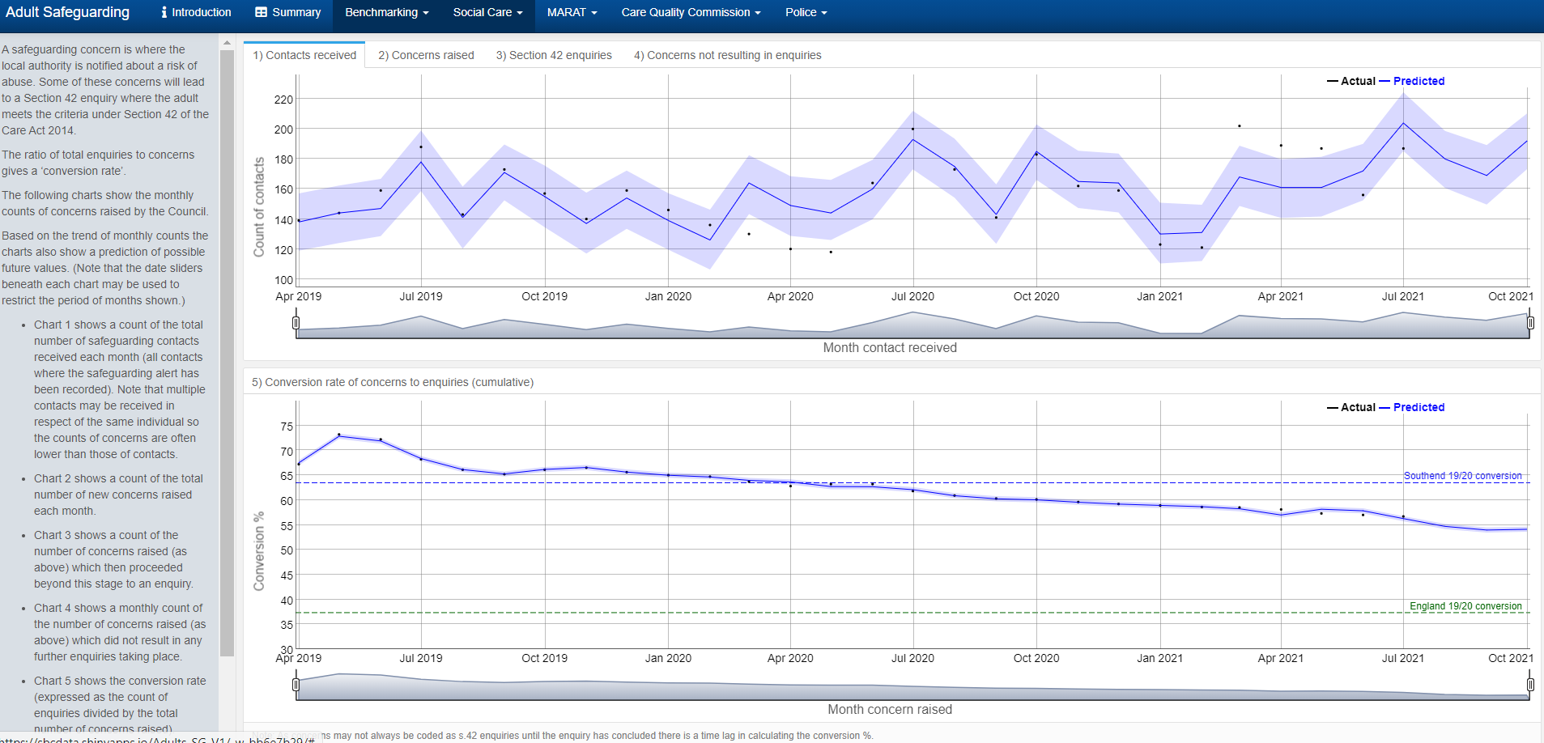
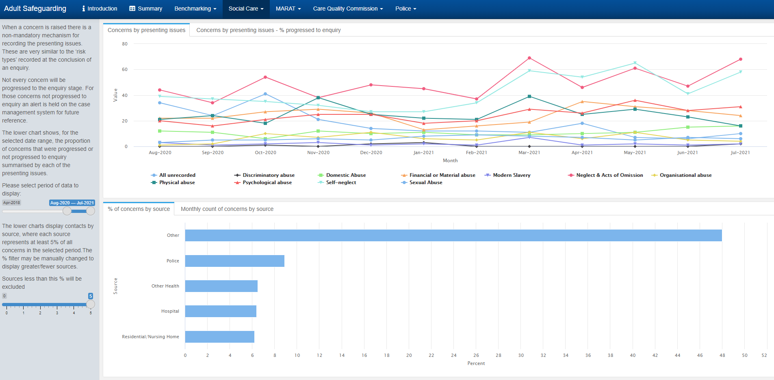

SCIE - https://www.scie.org.uk/safeguarding/adults/practice/sharing-information
http://www.ocerints.org/intcess19_e-publication/papers/412.pdf

